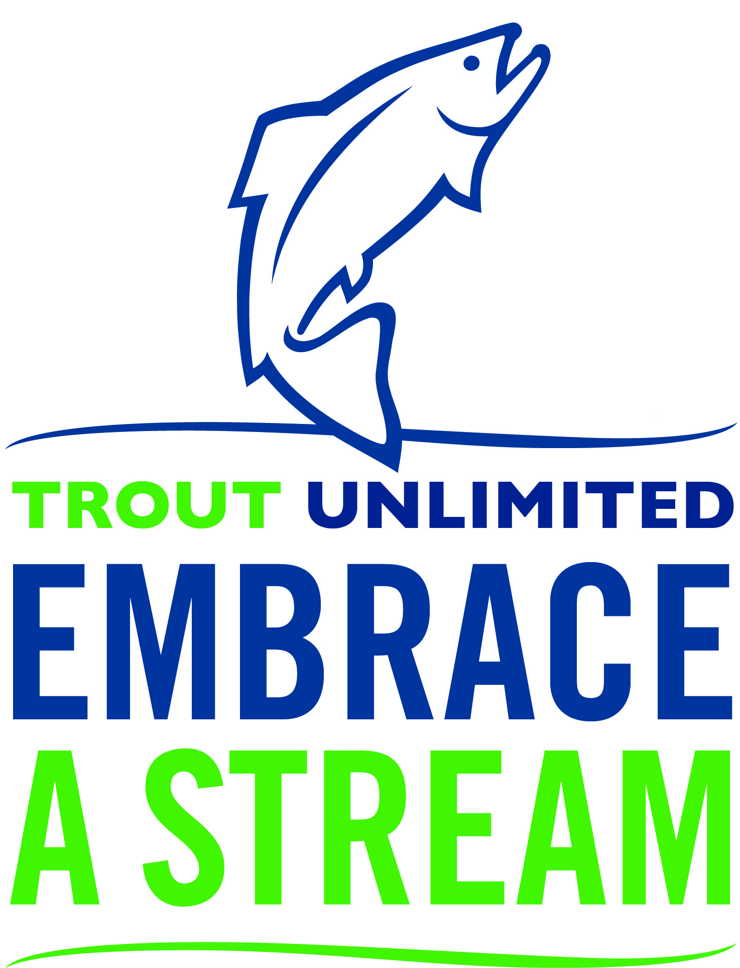

Embrace A Stream Final Project Report Form

Final reports are critical to providing an opportunity to leverage future funds and share your success story as well as provide an opportunity for your board to evaluate and reflect on your completed projects to facilitate the improvement of future projects. Chapters and councils who receive Embrace A Stream funding must complete a final report within two years of their award date.
Below you will find the final report form. Funded chapters and councils must submit their final report via the online portal by September 30th of their second year of the project (e.g.- projects funded in October 2018 must file a final report by September 30th, 2020) to be eligible for future Embrace A Stream funding.

General Information

Chapter or Council Name & State: ___________________________________________

Name of Project, Stream, or Watershed: _______________________________________
Chapter/ council POC Name:_______________________________________________

Chapter/ council POC Address: _____________________________________________

Chapter/ council POC E-mail: ______________________________________________

Chapter/ council POC Phone: ______________________________________________

Financial Information

Date of Award: EAS Grant Amount: Total Project Cost: Total Volunteer Hours: Did the Embrace-A-Stream grant leverage or help match any additional funding?
Yes ___ No

If so, please clarify in the table below.

Source of Leveraged or Matched Funds | Amount
Project Total | $

Outcomes and Evaluation

All TU chapters and councils should evaluate the impact of their projects. Evaluation involves identifying and measuring specific indicators to demonstrate the impacts of your work. To truly evaluate a project you must measure conditions before you begin work and after the project is completed. Examples of indicators are water flow or fish populations. Other volunteers may want to evaluate their projects by measuring the number of new members gained, the amount of publicity generated, or the increase in participant conservation knowledge. The indicators for your project will depend on what you are trying to accomplish. Please feel free to contact your regional committee member or Lisa Beranek (Lisa.Beranek@tu.org) with questions on project evaluation.

In 350 words or less, list the specific project objectives. What did you want to accomplish?

Please list the indicators used to evaluate these objectives.

Indicator 1:

Bef0re: After:
Indicator 2:

Before:
After:
Indicator 3:

Before:
After:

If you did not achieve your target objectives, please explain why in 350 words or less.

Other information

Did you collaborate with TU field staff during the implementation of this project? If so, please describe briefly in 350 words or less.

Do you have any plans to continue or expand the project? If yes, please describe in 350 words or less.

Please describe any publicity the project received, including dates, source, and type of coverage. (Please attach any press clippings.)

Please upload pictures from your project. Ideal pictures include visuals post-project (before and after photos), pictures of volunteers during the project, etc.

Other comments:

Thank you!

