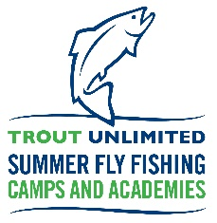
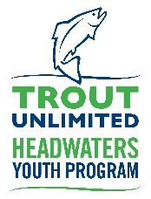
Camp Director's Community Commitment Conversation Framework
Introduction:
- Welcome campers and set a positive tone for the conversation.
- Briefly introduce the purpose of the talk: to ensure everyone understands and commits to creating a safe, inclusive, and respectful camp environment.
Key Points:
1. Respect for All:
- Explain the importance of treating everyone with kindness, regardless of differences.
- Emphasize that offensive conduct or statements based on race, gender, or any differences are not acceptable.
- Share examples of respectful behavior and encourage campers to share their thoughts.
2. Inclusivity:
- Discuss the value of making everyone feel welcome.
- Encourage campers to embrace differences and seek out new friendships.
- Highlight the role of each camper in creating an inclusive atmosphere.
3. Equitable Treatment:
- Explain the concept of equity and how it ensures everyone gets a fair chance to participate.
- Discuss the importance of not excluding anyone based on differences.
4. Open Communication:
- Stress the importance of open and respectful communication.
- Share that expressing concerns or seeking support is encouraged.
5. Conflict Resolution:
- Emphasize the importance of resolving conflicts peacefully and constructively.
- Encourage campers to seek help from counselors when needed.
6. Safe Space:
- Define what a safe space means at camp—physically and emotionally: a space where all campers feel they can be themselves without fear of unkind treatment.
- Discuss the impact of harassment and bullying and why it's not tolerated: such behavior can really hurt the victim and potentially ruin their camp experience, which is unfair.
7. Consequences of Violation:
- Explain who violations should be reported to—make sure all campers know who that person is and can easily recognize them.
- Discuss the range of consequences from not being permitted to participate in certain activities to dismissal from camp.

8. Camp Rules
- Finally, be sure to review the rules of the camp with all campers

Closing:
- Thank campers for their attention and participation.
- Reinforce the idea that, together, they can create an amazing camp experience.
- Encourage questions or thoughts from campers.
- Have a fun ice-breaker or something similar prepared to delve into after this conversation—the kids will have just gotten done sitting through a bit of a small speech, so reward that with a fun activity.

